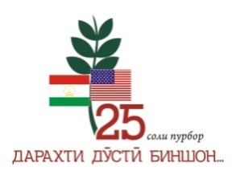

 

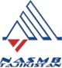

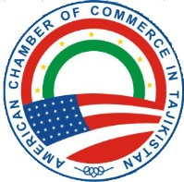

The National Association of Small and Medium Business of Tajikistan, within the framework of the Global Entrepreneurship Week (GEW) 2016, announces a call for applications for the contest **"Social Entrepreneur 2016: Woman and Business".**

If you are a woman:

* dreamed of creating your own business;
* your business is aimed at solving social problems,
* a private entrepreneur or a representative of small business,
* you need funds for the creation or development of social entrepreneurship *

• Fill out an application to participate in the contest!

• Use 3 minutes to present your project or start-up idea to business experts!

• Get a small grant!

* ***"Social entrepreneurship is a kind of business activity, which aims to address or mitigate the urgent social problems, and is located at the intersection of business and philanthropy.***

***But still, this is a commercial activity that is directed to such sensitive issues as social insecurity, unemployment, environmental protection, human rights etc. "***

The projects that will be accepted in the contest must improve the lives of people in general (or specific social groups), with the simultaneous creation of a sustainable financial base (or other material base15 semi-finalists will be selected by the Expert Commission based on their submitted applications. Participants will then their projects in Pitching sessions, 3-minute presentations to the Expert Commission of the contest. Semi-finalists will also be given an opportunity to take part in a master-class on how to present a project/business idea. .The date and time of the master class will be announced at a later date. .

**Note:** Participants are encouraged to use audio, photo and video materials to present their projects (during the 3 minute pitching session).

**The project must meet the following requirements:**

• The project must have a social impact, leading to the emergence of long-term, sustainable positive social change, improving the quality of life of the population in the covered region as a whole and / or members of socially vulnerable groups / populations and individuals in need of special support to develop their abilities and self-realization;

• Have a financially sustainable business model that allows the idea (project) to develop independently in the future;

• Period of the project does not exceed three months.

**Awards:**

One 1st place - 1500 US Dollars

Two 2nd places - 500 US Dollars

Two 3rd places - 250 US Dollars

Deadline for submission of documents for the contest is October 30, 2016. Applications for participation in the contest can be obtained from the Organizing Committee of the Contest by sending a request to e-mail: info@namsb.tj