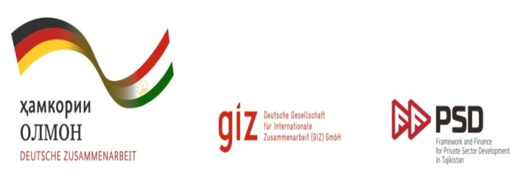

Dushanbe Economic Meeting 2015

Development of Agricultural Value Chains in Tajikistan

April 10th, 2015

National Library, Dushanbe, Tajikistan

Deutsche Gesellschaft für Internationale Zusammenarbeit (GIZ) together with Tajik partners aims to establish a tradition of conducting annual economic meetings with participation of international researchers in Tajikistan. This event should be the trademark of economic community of Tajikistan and regular event recognised not only within the country but also abroad.

Purpose and objectives of the Economic Meeting:
- establish tradition of a regular conference on applied economic issues;
- promote creation of a platform for exchange of views between economic decision-makers at the state level, academic teaching and research staff, independent researchers and students; involvement of economic community in a process of economic decision-making;
- join international network of economists as well as involve local experts who conduct their research abroad;
- support independent research.

As a rule, each year specific urgent issue is chosen. This year the Economic Meeting aims to bring together academics, policy makers, researchers, students, and wider interested public to debate and discuss issues of development of agricultural value chains in Tajikistan and other countries.

Possible topics include, but are not limited to the following:
- Agriculture and value chains as drivers of economic growth and employment in Tajikistan;
- Agricultural value chains in international context: WTO and Eurasian Economic Union;
- Value chains finance as a mean of strengthening agricultural development; attracting foreign investment;
- Linking farmers to market, inclusion of small farmers;
- Business cases of agricultural value chains in Tajikistan.

Practical information
- Each presenter will be allocated up to 20 minutes, including time for discussion.
- Working languages of the meeting – English, Russian and Tajik.
- Travel and accommodation expenses for speakers will be covered.
- There will be a limited number of travel and accommodation grants for students, who wish to visit Economic Meeting as attendants. Students must provide one page cover letter on the issue of the conference and how attending the Meeting will help in their studies.

Selected papers will be published in magazine “Tajikistan and Contemporary World” issued by Strategic Research Centre under the President of Tajikistan.

Selected business cases of agricultural value chains in Tajikistan will be offered for consideration of Ministry of Agriculture of Tajikistan, international development organisations and business community.

The best three papers from the Dushanbe Economic Meeting will be nominated for awards.

Important dates
- Application’s submission deadline: 28February, 2015.
- Notification of acceptance: 16 March, 2015
- Article and presentation submission deadline: 30 March, 2015

General inquires and submission of application and papers: takhmina.saidahmadzoda@giz.de

Application format

File name of the article should only contain Latin letters with the family name of the author. The paper should be typed in text editor Microsoft Word, font size Times New Roman (12 pt), line spacing- 1,5; 7-15 typewritten pages. Chart format should be in Excel, pictures and photographs in JPEG. Preferably, the formula should be typed using the Equation Editor.

Articles of the meeting will be accepted for publishing after peer review. Only those articles that fulfill the standards of economic content and format will be included in the magazine. Articles should be submitted in Russian or English.

Dushanbe Economic Meeting 2015

Development of Agricultural Value Chains in Tajikistan

Application Form

Complete application form should be send to email: takhmina.saidahmadzoda@giz.de

I want to participate in the meeting
Family name
Name
Patronymic
Academic degree
Position
Organization
Postal address_______________________________________________________
Email:
Phone number:

I am planning to
- Make a report
- Participate as a listener
- Present a poster paper

Information of the paper (author and title of the paper):

Summary of the paper:

Cover Letter for students

Students, who want to participate in the Economic Meeting and be awarded the travel and accommodation grants should write cover letter.

Topic: Development of Agricultural Value Chains in Tajikistan. How attending the Meeting will help in studies.

Format: should be typewritten in English, Russian or Tajik languages; 200-300 words.

